University of Ibadan
Department of Computer Science
First Semester Examination
Course Title: Theory of Computation
Course code: CSC 552
Time 2hours

Question 1
- With the aid of a diagram explain the order of complexity of Finite State Machine, Push Down Automata and Turing Machine. (3mks)

- What are the language that each of the machines accepts? (3mks)

- Draw a Turing Machine with input tape alphabets a^{n}, b^{n} for n ≥1, with tape in control. (5mks)

- What is blank in Turing machine? (2mks)

- A Turing Machine can be defined by a set of 7 tuples discuss. (7mks)

Question 2
- Explain the operations on the tape in Turing machine with appropriate diagram. (6mks)

- List out all the steps in Rule of Operations 1 and 2 with diagrams and explanation. (14mks)

Question 3
- Discuss Turing’s Thesis and its arguments for accepting the thesis. (3mks)

- Design a Turing Machine which recognizes the language L = 01*0*1. (6mks)

- What makes a language to be Recursively Enumerable? (3mks)

- Given a Turing Machine, will it halt when run on some particular given input? (3mks)
- List and Explain the outcomes of non-deterministic computation. (5mks)

Question 4

- Design a Turing Machine that recognize the left end of the tape, use $ sign in your design. (7mks)

- Compare two strings of Turing Machine and decide if the strings in W # W are the same {W # W / W Ɛ {a,b,c}*}. (7mks)

- Build a Turing Machine to recognize the language L = 0^{N}1^{N} and write the algorithm for the machine. (6mks)

University of Ibadan
Department of Computer Science
First Semester Examination
Course Title: Theory of Computation
Course code: CSC 552
Time 2hours

Marking Guide for CSC 552
Question 1
- With the aid of a diagram explain the order of complexity of Finite State Machine, Push Down Automata and Turing Machine.
Solution

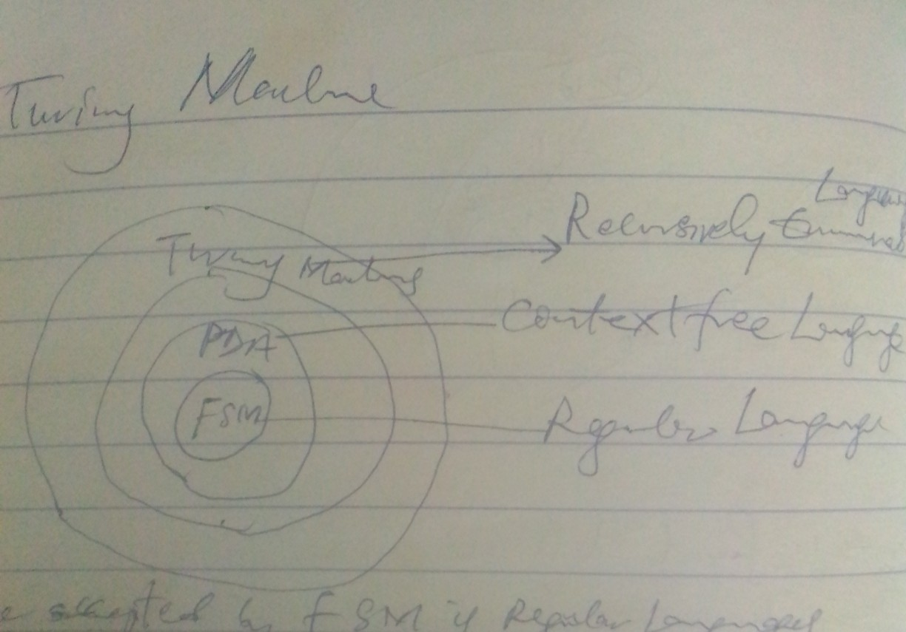

(2mks)

- What are the language that each of the machines accepts (3mks)

Solution
FSM accepts Regular Language (1mk)
PDA accepts Context Free Language (1mk)
TM accepts Recursively Enumerable Language (1mk)

- Draw a Turing Machine with input tape alphabets a^{n}, b^{n} for n ≥1, with tape in control.(5mks)

Solution

A | A | A | a | A | a | a | B | B | B | b | b | b | b | ﮞ | ﮞ | ﮞ | ﮞ | . | .
x x x y y y
(5mks)

- What is blank in Turing machine?
Solution
The blank is a special symbol ﮞ used for filling the infinite tape in Turing machine and it does not belong to the strings in alphabet ∑, ﮞ ≠ ∑ (3mks)

- A Turing Machine can be defined by a set of 7 tuples discuss. (7mks)

Solution
(Q, ∑, r, ∂, qo, b, F)

Q Non empty set of state (1mk)
∑ Non empty set of symbols (1mk)
R Non empty set of Tape symbols (1mk)
∂ Transition function defined as Q x ∑ r x (R/L) x Q (1mk)
q_{o} Initial state (1mk)
B Blank symbol (1mk)
F Set of final states (Accept state & reject state) (1mk)

Question 2
- Explain the operations on the tape in Turing machine with appropriate diagram

Solution
Read / Scan symbol below the tape head (0.5mk)
Update / write a symbol below the tape head (0.5mk)
Move the tape head one step LEFT (0.5mk)
Move the tape head one step RIGHT (0.5mk)

Infinite sequence
a | a | A | a | a | b | B | b | b | ﮞ | ﮞ | ﮞ | ﮞ | ﮞ | . | .
Tape head alphabets ∑ = {0, 1, a, b, x, y, z_{o }} (4mks)

- List out all the steps in Rule of Operations 1 and 2 with diagrams and explanation
Solution
Rule of operation -1
At each step of the computation:
- Read the current symbol (0.5mk)
- Update (i.e. write) the same cell (0.5mk)
- Move exactly one cell either LEFT or RIGHT (0.5mk)
If the machine is at the left end of the tape, and trying to move to the left, do not move, stay at the left end. (1mk)

a b, R
Direction to move RIGHT OR LEFT
Symbol to Read
Symbol to Write

(5mks)

If you don’t want to update the cell, just write the same SYMBOL

1 1, L

Tape head symbol 1, write the same to the same cell (2mks)

Rule of Operation -2
- Control is with a sort of FSM (similar to FSM or PDA) (0.5mk)
- Initial state(0.5mk)
- Final state (there are two final states) (.05mk)
    - The Accept State (Strings accepted) (0.5mk)
    - The Reject State (Strings rejected) (0.5mk)
Computation can either
- HALT and ACCEPTED(0.5mk)
- HALT and REJECTED (0.5mk)
- LOOP (the machine fails to HALT) (0.5mk)

Loop is a special case; it neither goes to accept state nor to reject state. (0.5mk)

Question 3
- Discuss Turing’s Thesis and its arguments for accepting the thesis

Solution
Turing thesis states that any computation that can be carried out by mechanical means can be performed by some Turing Machine. (1mk)
Arguments for accepting this thesis are:
Anything that can be done on existing digital computer can also be done by Turing Machine. (1mk)
No one has yet been able to suggest a problem solvable by what we consider on algorithm, for which a Turing Machine Program cannot be written. (1mk)

- Design a Turing Machine which recognizes the language L = 01*0*1.

Solution

1 YR 0 XR

0 X R 0 XR 1 YR
A
B
C
D

1 1R ﮞ ﮞ R ﮞ ﮞ R 1 1R ﮞ ﮞ R
ﮞ ﮞ R 0 0R
Accept
Reject

(6mk)

What makes a language to be Recursively Enumerable?

Solution
A language L and ∑ is aid to be Recursively Enumerable if there exist a Turing Machine that accepts it (3mk)

Ans

0 | 0 | 0 | 0 | 1 | 1 | 1 | 1 | ﮞ | . | . | .
X X X X Y Y Y Y (3.5mks)

Algorithm:
Change “0” to “x” (0.5mk)
Move RIGHT TO FIRST “1” (0.5mk)
If none Reject (0.5mk)

- Given a Turing Machine, will it halt when run on some particular given input?

Solution:
- In general, we can’t always know. (1mk)
- The best we can do is to run the program and see whether it halts. (1mk)
- For many programs, we can see that it always halts or sometimes loop. (1mk)

- List and Explain the outcomes of non-deterministic computation.

Outcomes of Nondeterministic Computation:
Accept: If any branch of the computation accepts, then the nondeterministic TM will Accepts. (1mk)
Reject: If all branches of the computation HALT and REJECT (i.e. no braches accepts, but all computations HALT) then the Nondeterministic TM Rejects. (1mk)
LOOP: Computation continues but ACCEPT is never encountered. Some branches in the computation history are infinite.(1mk)

Question 4
- Design a Turing Machine that recognize the left end of the tape, use $ sign in your design. (7)mks

Solution
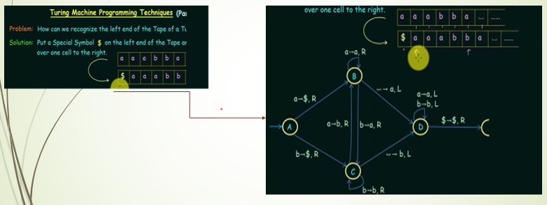

- Compare two strings of Turing Machine and decide if the strings in W # W are the same {W # W / W Ɛ {a,b,c}*}. (6mks)
Solution

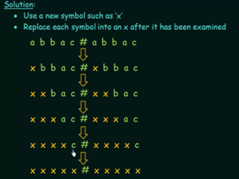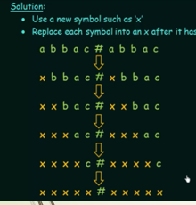

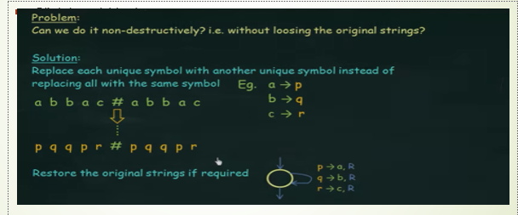

- Build a Turing Machine to recognize the language L = 0^{N}1^{N} and write the algorithm for the machine. (6mks)
Solution


